 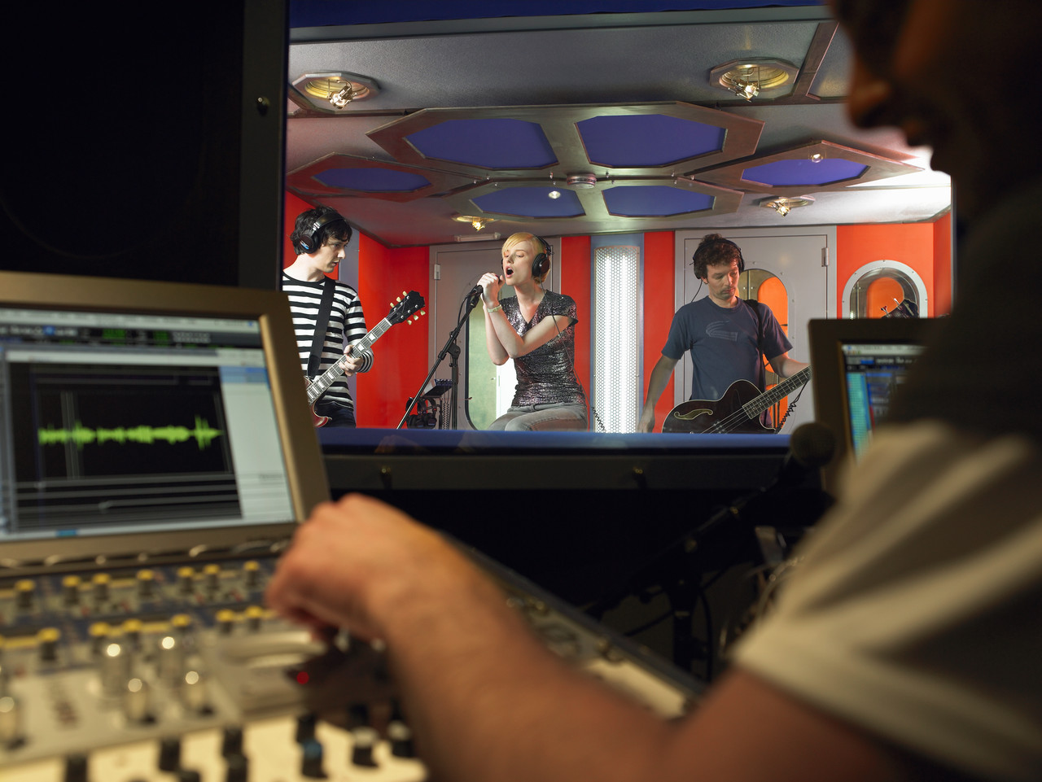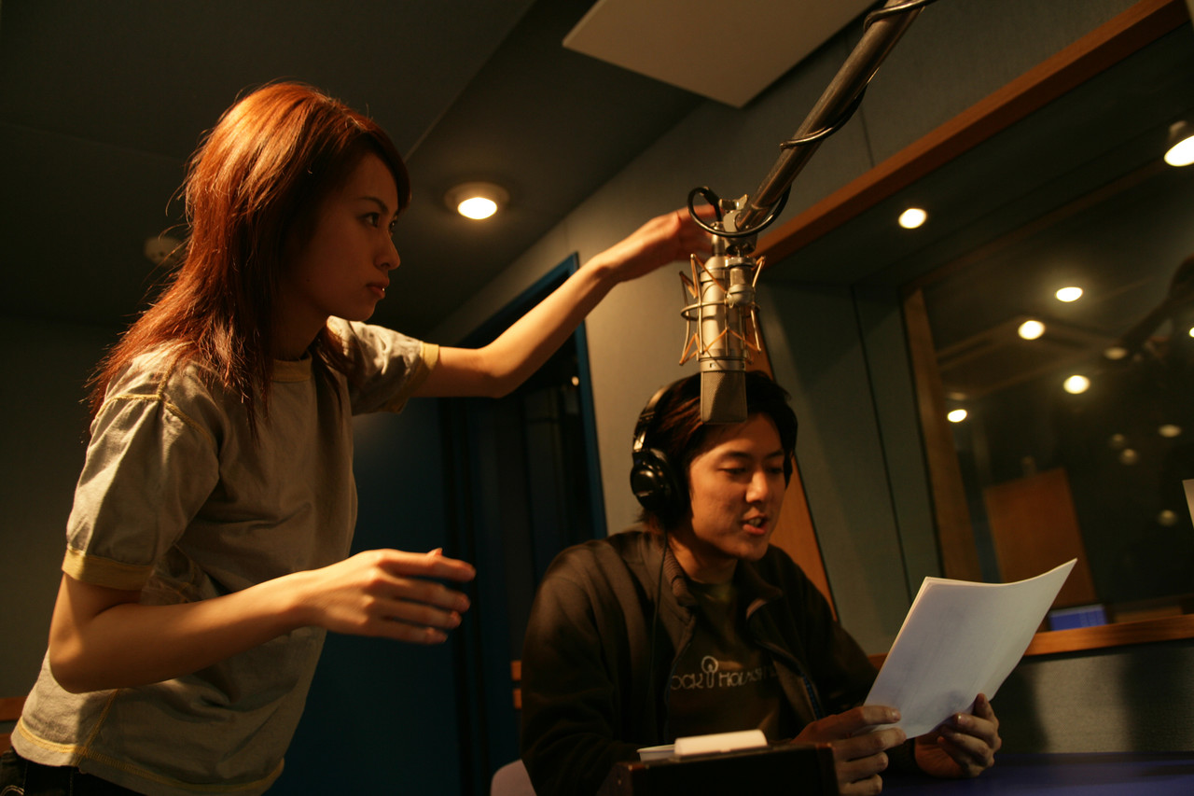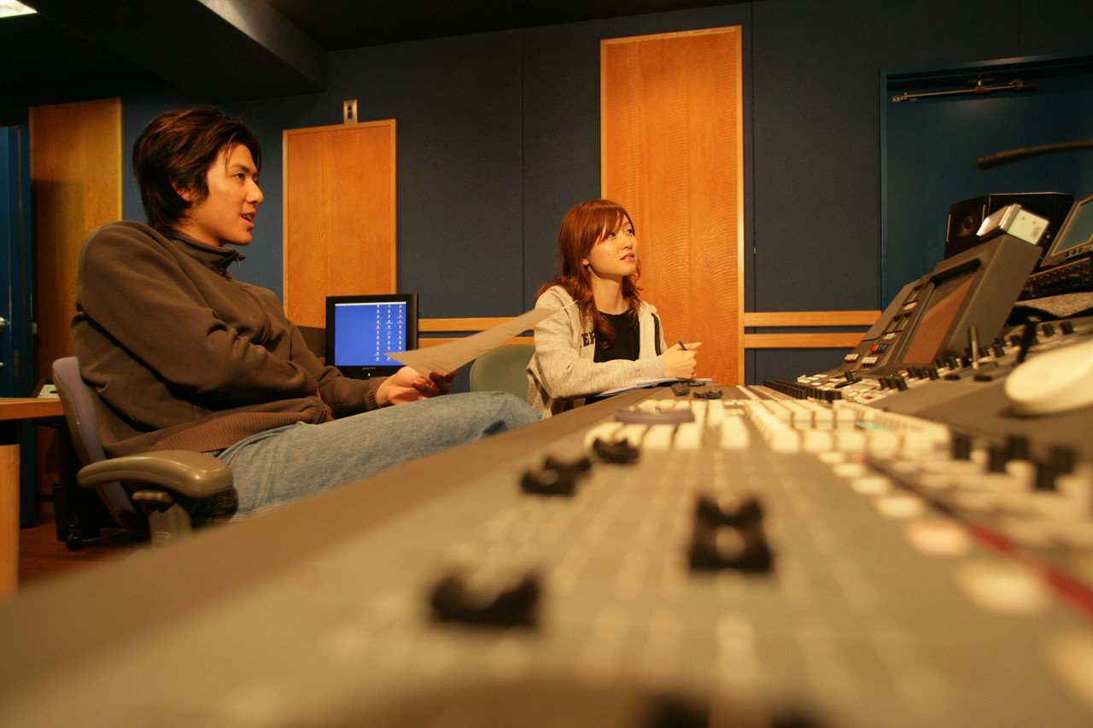

* Parents are a critical part of the process. Please contact the academy for important parent information dates and ideas where you can help.
* Business and community members are always needed to provide mentors that will guide a student through the project and industry professionals that can assess the final presentations. Contact us today to be matched with a Capstone Team.
* Join our blog!

# How Can I Help?

www. insertwebsitehere.com

T-STEM Academies

Capstone projects

* Each Capstone Team is composed of one or more student members
* Capstone Teams have a campus advisor that provides guidance throughout the process
* A community/business advisor can assist in logistics and can be a liaison
* Community business members can assist with developing project ideas to assisting in judging project results

For more information about capstone projects, visit our website at

# Key Players

# Categories of Capstone Project

# Hallmarks of Capstone Projects

[www.ode.state.oh.us/ctae](http://www.ode.state.oh.us/ctae)

**Research**

Research is collected and analyzed to begin formulating a solution to the problem or question. The student uses various methods and sources to investigate the problem.

**Authenticity**

Resources exist within the community and beyond to support this project. The capstone project represents a real problem encountered by individuals in this career field. Working to resolve the problem, the student demonstrates proficiency in technical and academic competencies.

**Work-based Learning**

The problem is connected to an area within the student’s career field. The student selects an adult from an advisory committee, business partner or postsecondary partner to work closely with on the project

**Academic Rigor**

The project is cross-curricular and challenges the student to apply knowledge related to both academic and technical subject areas. The project is aligned with appropriate academic content and technical standards.

**Professional Relationships**

The student works closely with adults of content expertise. Adults collaborate with each other and with students on the development and evaluation of projects. Students prepare professional oral and written communications for adult audiences.

**Presentation**

The student produces a multimedia presentation detailing problem identification, research and the student’s solution or recommendation. The presentation is the culminating experience in which the student demonstrates what has been learned.

**Assessment**

Project criteria is communicated to the student and is used to gauge learning. Assessment is formative, with multiple checkpoints along the way, providing feedback to the student. Adults outside the classroom help the student develop a sense of real-world standards. The student’s project is documented in a Career Passport.

are generally done in cooperation with various members

**Designing a product, service or system** Identify needs that could be met by new products, services, or systems and create solutions for meeting them;

**Improving a system** Develop an understanding of the way systems of people, machines, and processes work; trouble shoot problems in their operation and devise strategies for improving their effectiveness; or

**Planning and organizing an event or activity** Take responsibility for all aspects of planning and organizing an event or activity from concept to completion, making good use of the resources of people, time, money, materials and facilities. This event must include content standards.

**signing a product, service or system** Identify needs that could be met by new products, services, or systems and create solutions for meeting them;

* **Improving a system** Develop an understanding of the way systems of people, machines, and processes work; trouble shoot problems in their operation and devise strategies for improving their effectiveness; or
* **Planning and organizing an event or activity** Take responsibility for all aspects of planning and organizing an event or activity from concept to completion, making good use of the resources of people, time, money, materials and facilities. This event must include content standards.
* **system** Identify needs that could be met by new products, services, or systems and create solutions for meeting them;
* **Improving a system** Develop an understanding of the way systems of people, machines, and processes work; trouble shoot problems in their operation and devise strategies for improving their effectiveness; or
* **Planning and organizing an event or activity** Take responsibility for all aspects of planning and organizing an event or activity from concept to completion, making good use of the resources of people, time, money, materials and facilities. This event must include content standards.

*“Capstone projects are intended to be intensive active learning projects requiring significant effort in planning and implementation…and substantial final written work product. “*

-Duke University